# Git Insights

จำนวน 2 Repos

## Repo 1 Project_APS_CE_Document

### Commits

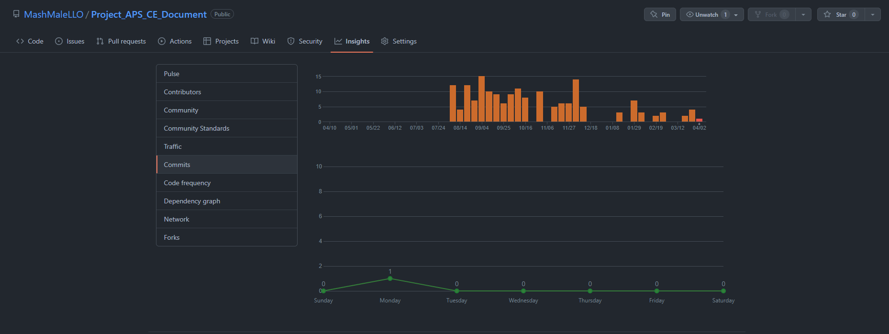

### Contributors

### A screenshot of a computer Description automatically generatedCommit Messages

## Repo 2 Project_APS_CE_DEV

### Graphical user interface, application Description automatically generatedCommits

### Contributors

### Commit Messages

